Python using Eclipse

Eclipse is the most popular free Integrated Development Environment (IDE) in use today. It was originally developed for Java programming but now supports numerous other programming languages and frameworks. Eclipse is actively supported by Google, Novell, IBM and Oracle

Eclipse is available from http://www.eclipse.org/downloads/. Any of them will do the job, I currently use the Eclipse IDE for Java EE Developers. You must have Java installed on your machine for Eclipse to work (it may install Java automatically).

To use Python in Eclipse you need to install the PyDev plugin which can be found at http://pydev.org/. You must have both Java and Python installed on your machine, Eclipse can handle multiple versions of Python.

To install PyDev in Eclipse go the Eclipse Menu Help->Install New Software. This brings up the following screen

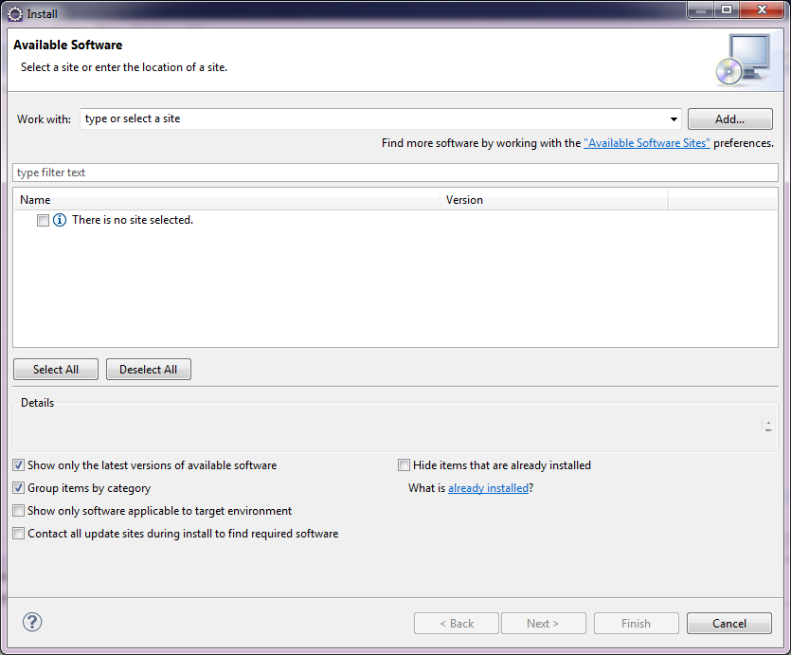
On the PyDev download page there is a link to update page, it will be something like
http://pydev.org/updates
Copy this link into the Work box and select add. A pop up screen lets you add a Repository name, keep the local as it is. Once you click OK the main section of the screen list the available PyDev plug ins. You will only need PyDev. Select this and click next and go through the next couple of screen which ensure that you accept the PyDev licence. Clicking Finish will install this plug in to Eclipse.

You can see all the installed plugin at the Help -> About Eclipse menu.

Workspace

The folder where all the Python files are kept is called a Workspace. Inside this you can separate your programming projects into separate folders. To create a new workspace go to File -> Switch Workspace ->Other. Here you can navigate to a folder which will become your Workspace area. Eclipse places some files in this folder to help keep track of your work. You can have as many Workspaces as you like but only one can be opened at any one time. I usually create a separate Workspace for each of the languages that I am working on.
You can change your workspace using File -> Switch Workspace. Eclipse keep s track of some of these but if yours is not in the list you can navigate to it under the Other option.
Changing a workspace caused Eclipse to reload.

Projects

Inside a Workspace you can have as many projects as you like, each project can have any number of files and folders(called packages). To create a new project go to File -> New. Here you must select PyDev Project (for a new Python project). If it is not in the short menu you will need to select Other to bring up the New Selection Wizard
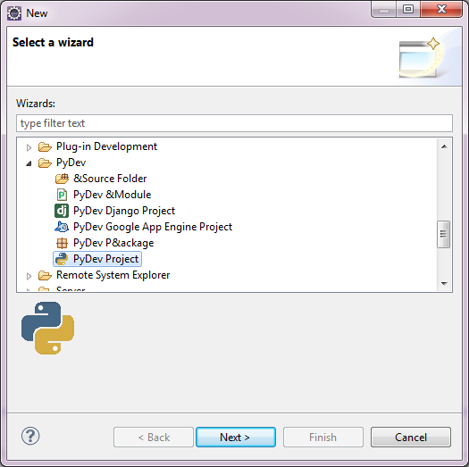
This wizard selects all the possible projects and files from all the plugins that you have currently installed. For a PyDev Project you need to select it from the PyDev folder as shown.
Clicking Next bring up the Create Screen
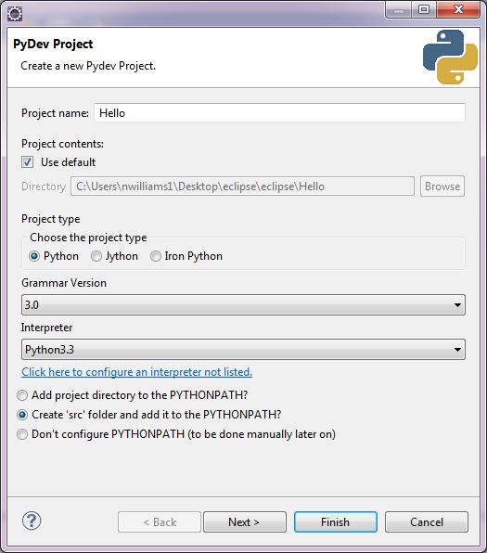
Here you must give the project a name. You should also set the Grammar Version and Interpreter to the version of Python that you are using. Finally you need to select one of the buttons at the bottom. The one currently selected creates a folder call src in the project which is a convenient place to put all the program files and keep them organised in large projects.

This then creates a project and installs the correct version of Python to be used by the Project. On the Eclipse Screen that looks like this:

Now we need to create a file for our programs.
Click the src folder and select File -> New (this is also available off the right button). What you need to select is PyDev Module. This brings up the following wizard
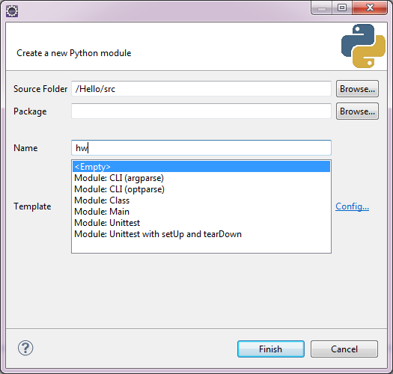
You simply need to give your file a name and press Finish, you can ignore the other options.

This brings you to the main screen which should look something like this
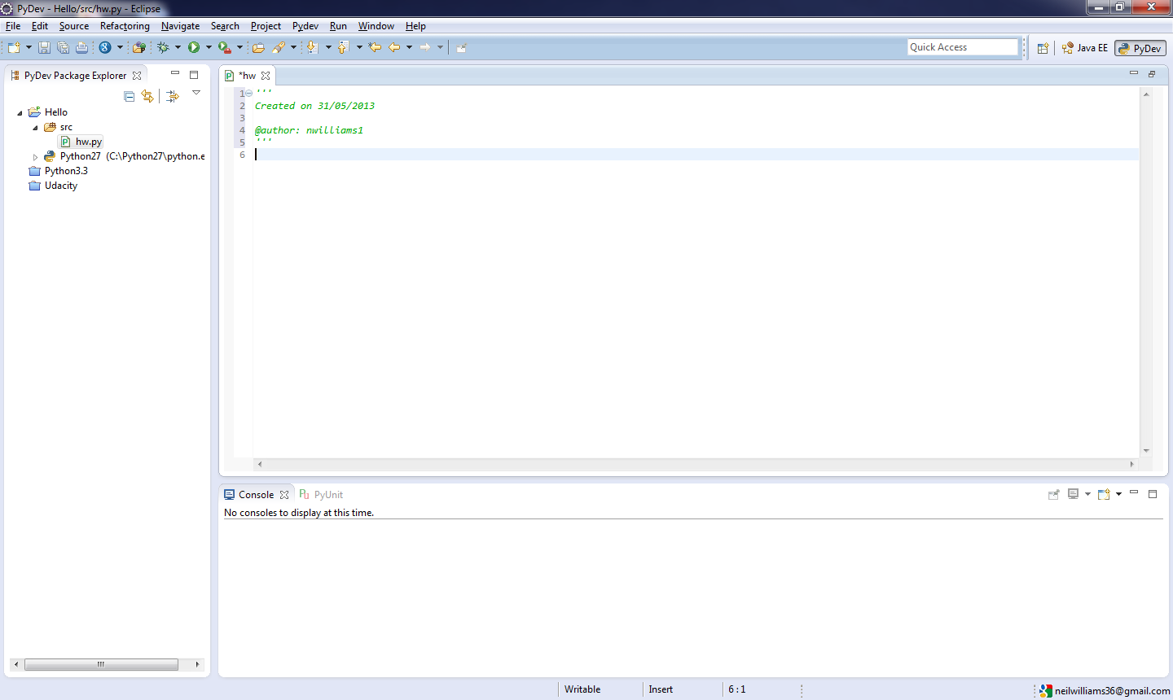
The left panel (called Explorer) is where you can see your files and open them by double clicked them.
The middle upper panel is the text editor for Eclipse.
The lower panel is the Console where the results of your program running can be seen. There are other panels available which can be actived at Window -> Show View. Eclipse is highly customisable so you can move the panels around into any combination that you want.

To run a program that you have created a run configuration file (since you are using a plugin to Eclipse for Python it does not know how to run Python files by default.) The run configuration file is tied to a particular python file so you need to create a new one for every file that run (or modify an existing one)

To create a run configuration file go to Run As -> Run Configurations. either from the right button or from the Run menu. This brings up the following window
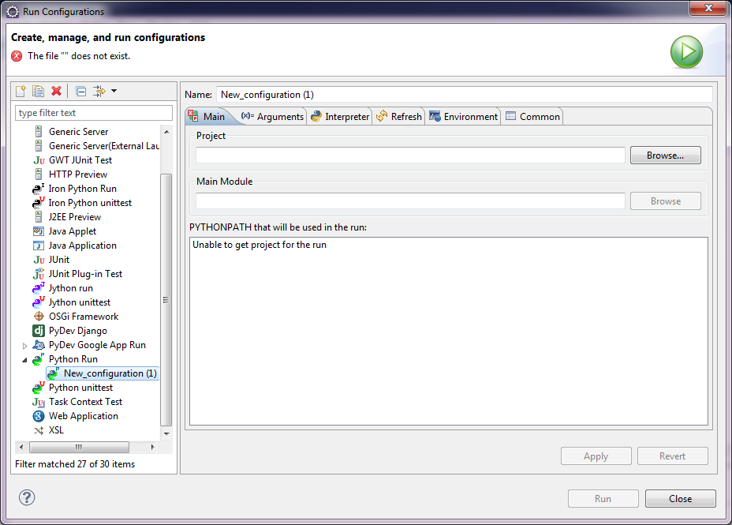
There are a number of settings that need data;
Name: This is the name that will appear in the Run As menu. This needs to be set
Project: Use the browse button to find the current Project (in this case Hello)
Main Module: Use the browse button to find the current file (in this case hw.py which is inside the src folder)
That should be all that you need to set this up.
To run you file you need to select Run from the Run menu or from the Run Button (the green button with a white arrow)
The Run Button will run the last used configuration. You can access other recently used configuration from the drop down menu beside it.
Each file you create will need its own run configuration file or you can just create one file and edit it to suit the file you wish to run

